**Central Bank Dealers Range**

|  |
| --- |
|  |
|  |
|  |
|  |
| Central Bank Dealers Range |
|  |
|  |
|  |
|  |

A standard deviation is the exact same range as the CBDR, its a symmetrical swing

|  |
| --- |
| 4 Standard Deviation |
| 3 Standard Deviation |
| 2 Standard Deviation |
| 1 Standard Deviation |
| Central Banlc Dealers Range |
| 1 Standard Deviation |
| 2 Standard Deviation |
| 3 Standard Deviation |
| 4 Standard Deviation |

Most Sell Days Create HOD

Most Buy Days Create LOD

|  |  |  |
| --- | --- | --- |
|  | 4 Standard Deviation |  |
|  | 3 Standard Deviation |
| 2 Standard Deviation |
| I Standard Deviation |
| Central Bank Dealers Range | --. |
|  | 1 Standard Deviation |
| 2 Standard Deviation |
| 3 Standard Deviation |
| 4 Standard Deviation |  |

**Ideal Sell Days Create HOD**

|  |
| --- |
| **4 Standard Deviation** |
| **3 Standard Deviation** |
| **2 Standard Deviation** |
| **1 Standard Deviation** |
| **Central Bank Dealers Range** |
| **1 Standard Deviation** |
| **2 Standard Deviation** |
| **3 Standard Deviation** |
| **4 Standard Deviation** |

**Ideal Buy Days Create LOD**

4 standard deviations, is going to be on very high impact news. Or price can go to the 4th deviation to create a new york session market reversal profile

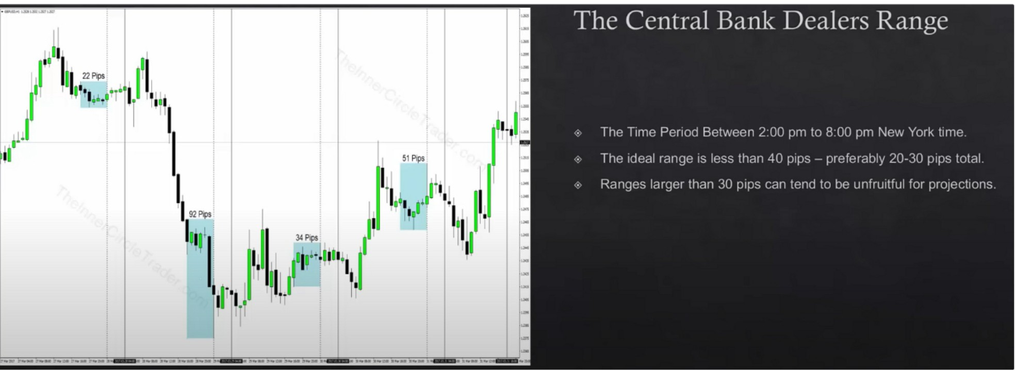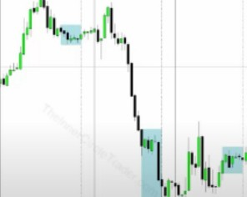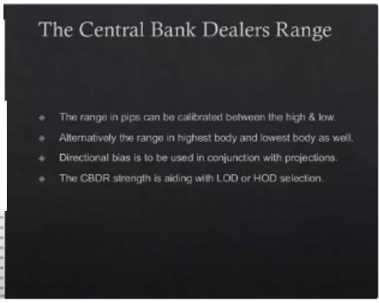

*I*

*\r*

1, -

.,,

I -

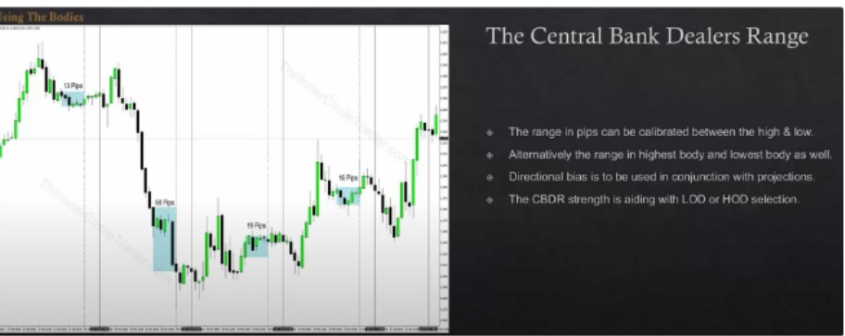

We can use the wicks, we can use the bodies as well. ICT likes to use the bodies ICT doesn't trade everyday, its not productive

There are higher probability days then others

CBDR projections can help in finding where the low of the day on a bullish day will be, vice versa for high of the day on a bearish day

Just because we use the bodies, we still have to look at the wick ranges everytime

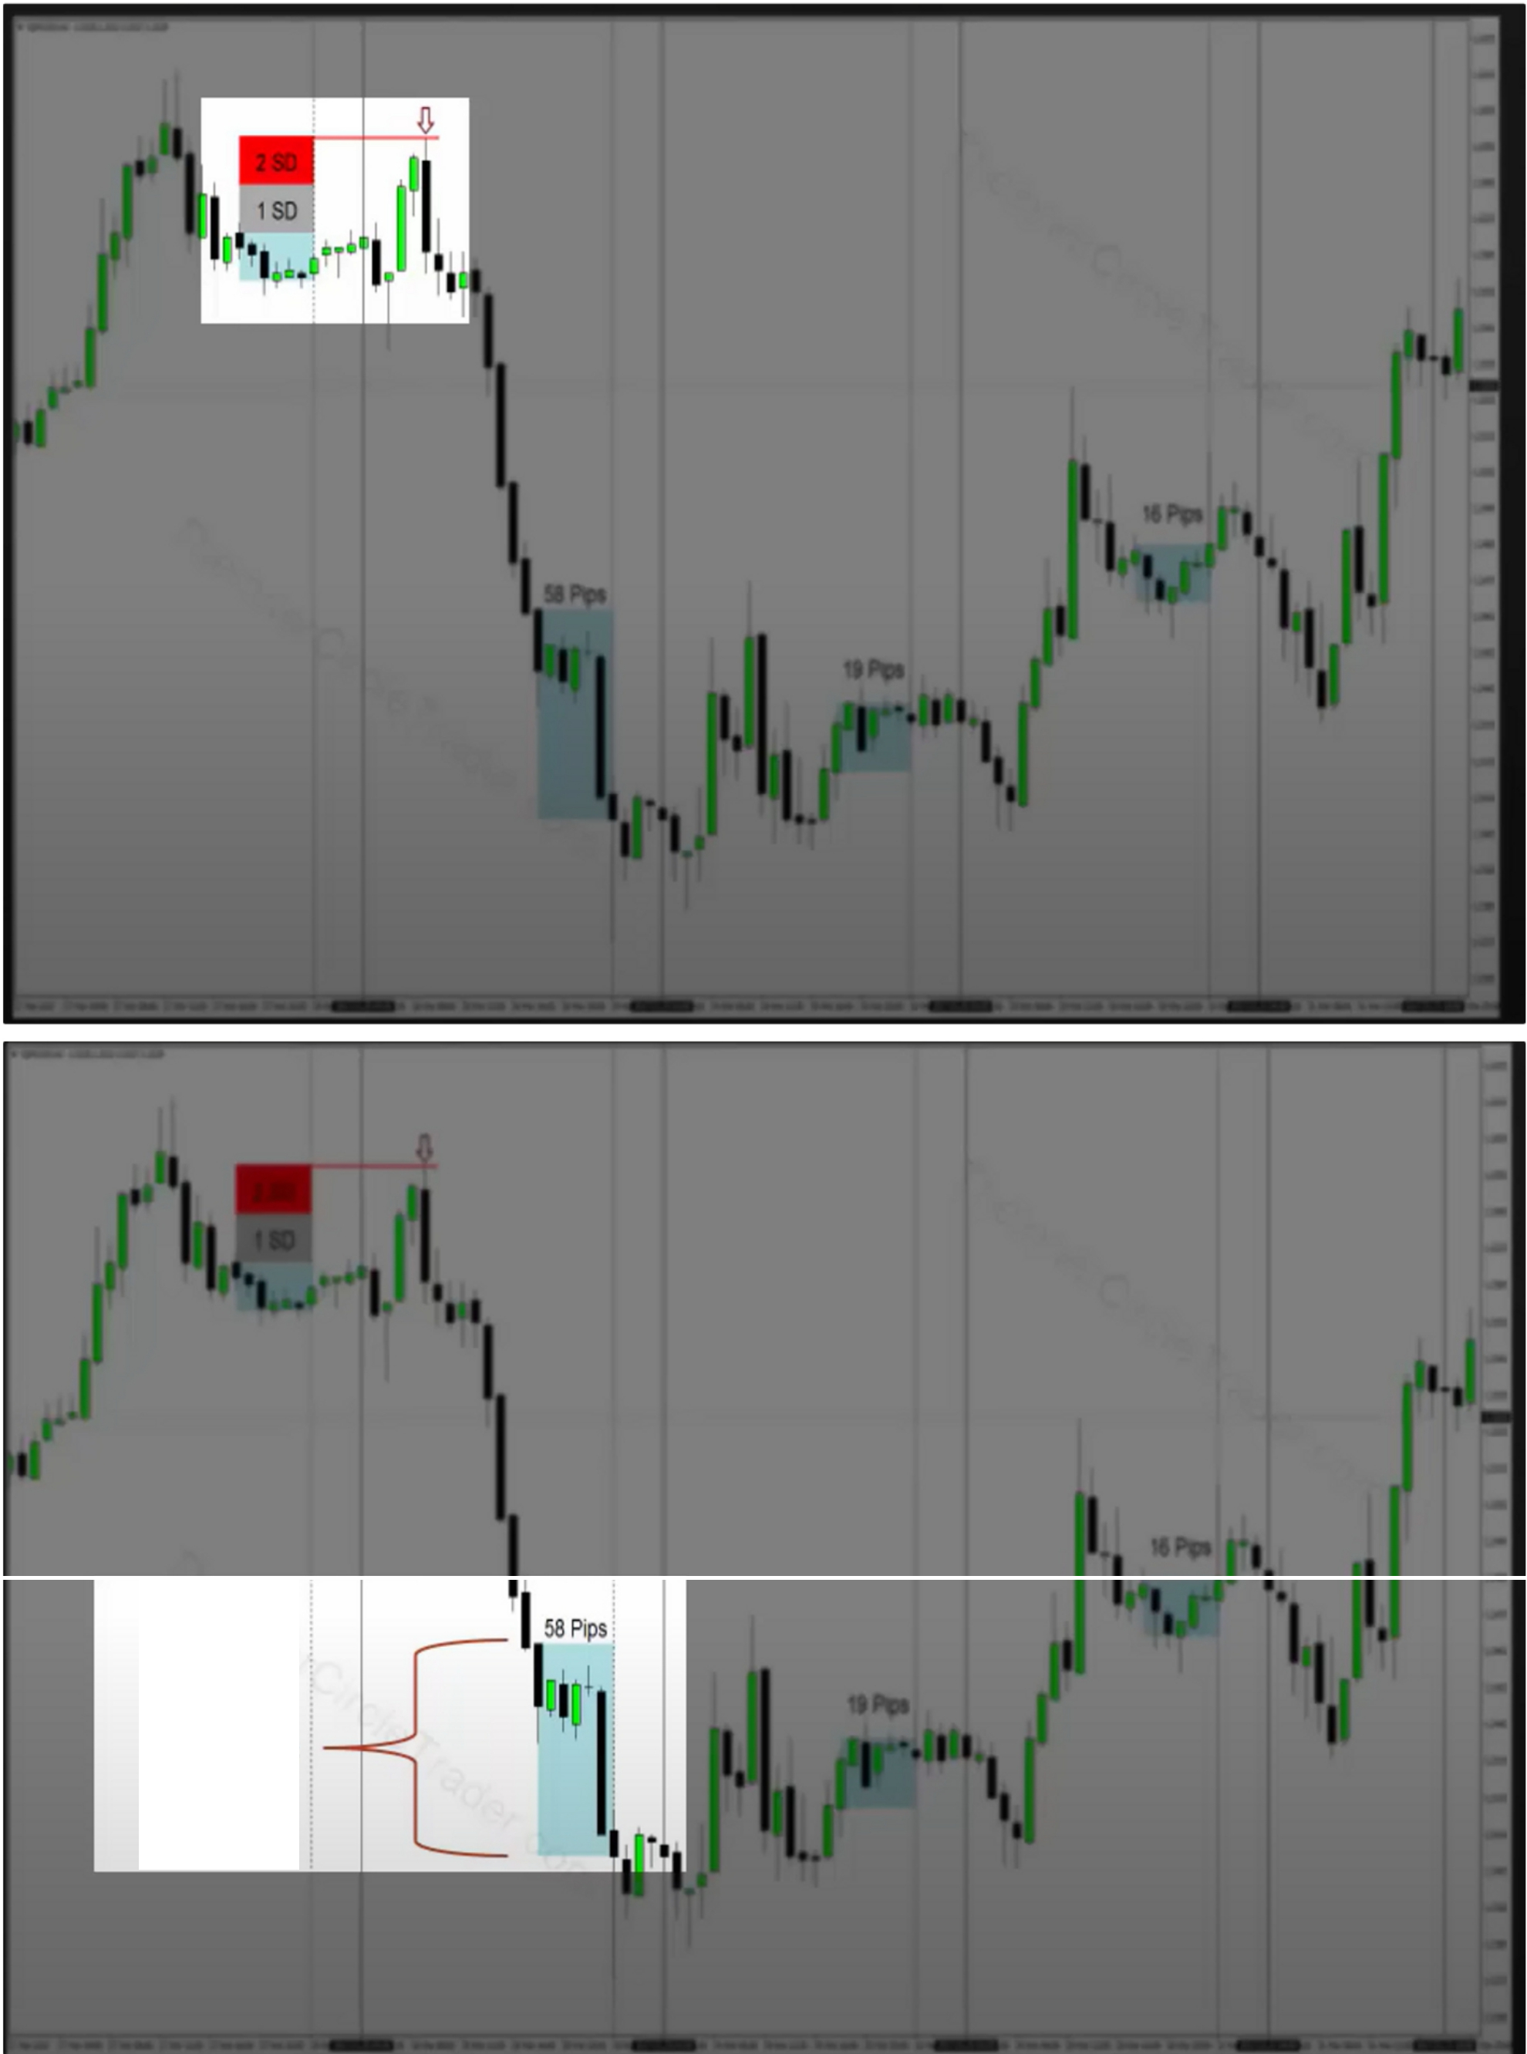**Too Large**

We cant use the CBDR criteria for daytrading on this day, we can look at scalping The daily candle is around 100 pips generally

We have to have a bias, what will the next 3 days likely do, whats the price likely going to do this week, where we at seasonaly, where we at quarterly, do we have a quarterly shift, do we have IPDA PD arrays that havent been met yet?

So if we come into a premium array on the daily and we expect bearish price, then we can look at london open for 1-2 or maybe 3 standard deviations higher to create the high of the day. Also add seasonal tendency to it

When we blend all this together, it becomes higher probability

Arjo I Twitter, lnstagram I Linktree

Linktree. Make your link do more.

, https://t.co/HhmmTN1fUI

JavaScript is not available.

"# https://twitter.com/arjoio